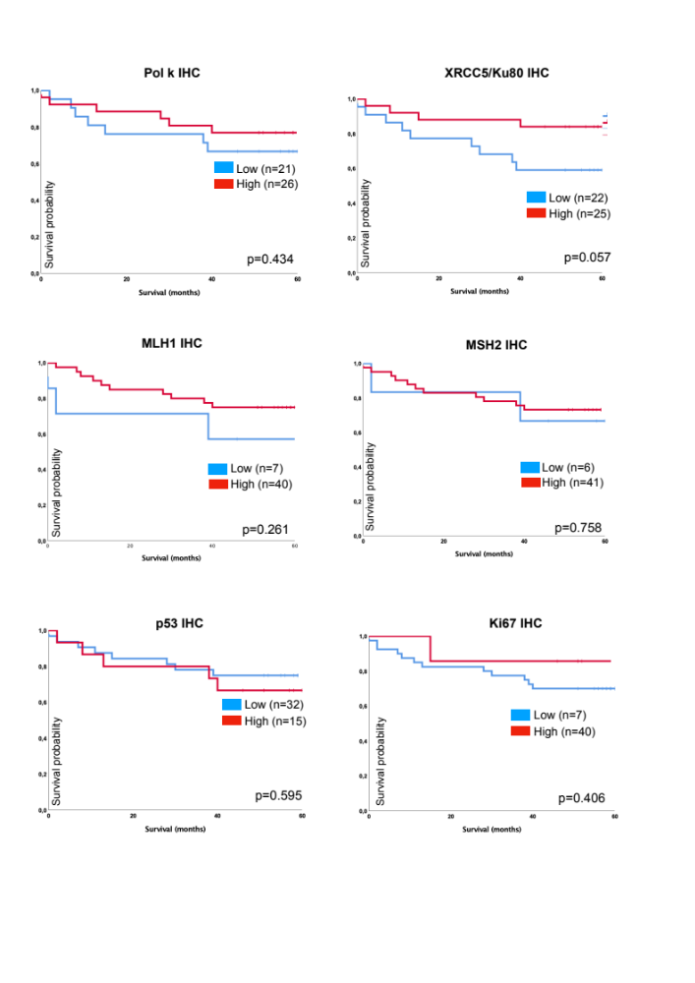
Supplementary Figure S5: Associations of overall survival of IHC scores of Pol k, XRCC5/Ku80, MLH1, MSH2, p53 and Ki67 utilizing Kaplan-Meier curve.

